Activity Introduction
Curriculum outcome
1a) S1-4-01 Use a coordinate system to locate visible celestial objects, and construct an astrolabe to determine the position of these objects.
Include: Altitude, Azimuth

1b) The purpose of the activity is for students to learn to locate celestial objects in the night sky and plot their location using the altitude-azimuth coordinate system. The altitude-azimuth coordinate system consists of the altitude of an object in the sky, given in degrees from zero to 90 (we will use the constructed astrolabe to find this), and the compass direction of the object, given in degrees between zero and 360 (zero being due north, 90 due east, 180 due south, and 270 due west).

1c) The justification for the approach I have taken is that celestial objects are more easily viewed at night and since students do not attend school at night. It is justified that they perform this activity on their own time when it can be done at night.

1d) It is important that the students understand what azimuth and altitude are before starting this activity.

The Altitude of a celestial body is its angular distance above the Horizon.

The Azimuth of a celestial body is the bearing of the body from your position, as measured clockwise from true North.

Class Procedure
- Begin the class by explaining what azimuth and altitude are and how they relate to locating celestial objects.
- Demonstrate to students how to find celestial objects azimuth using a compass. To find azimuth you trace a line straight down from the object to the nearest horizon point, and then read the bearing on your compass where that point hits. Remember that 90۫۫۫۫۫ would be due east, 180۫ would be due south, 270۫ would be due west, 0۫ or 360۫ would be due north. So if your object was 30۫ , you would write your object as being 30۫ North, North, East or 30۫ NNE.
- Work with students to construct astrolabes.
- materials needed:
- thick corrugated cardboard (about 8.5" x 11" or similar)
- scissors
- 20 cm of thin string or colored fishing line
- weight (washer, nut, or similar object that can be tied onto the string)
- large drinking straw (at least 0.5 cm in diameter)
- glue
- transparent tape
- Demonstrate to students how to use their astrolabe to determine celestial objects altitude. To find the altitude of the object you need to pinch the string with your free hand, against the scale on the astrolabe. Remember that 0۫ is your horizon and 90۫ is straight above you.
- Show students some examples of altitude and azimuth coordinates for a couple celestial objects.
E.g)
Evening planets one hour after sunset (W to E):
Planet | Altitude | Azimuth
Uranus | 20º | 249º WSW
Mars | 60º | 91º E
- Hand out Locating Celestial Objects in the Night Sky assignment/activity and explain to the students what is expected of them. Tell students that the assignment is to be done on their own time, and recordings are to be taken two times a week for the next three weeks. Tell students that recordings should be taken a minimum of three days apart.
- Go over the star chart procedure and field any questions on it.
- Provide students with time to pick the objects they wish to view. Students are to use this time to research their chosen objects to make certain that they are able to be viewed from our location at this time of year.

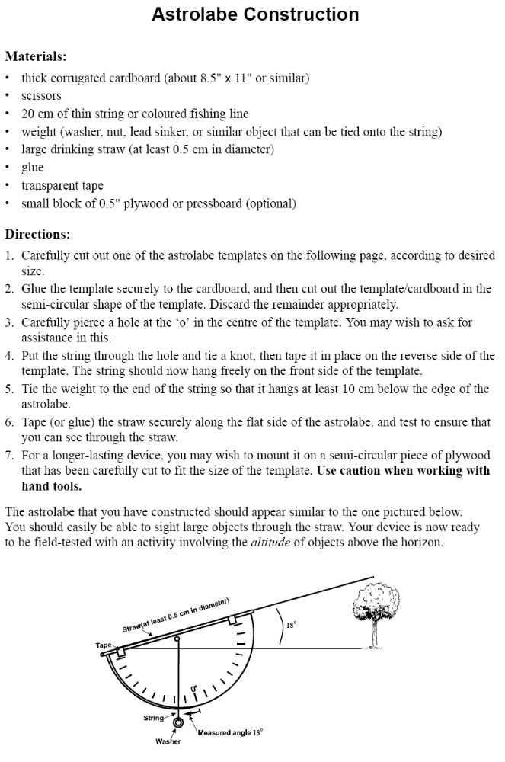
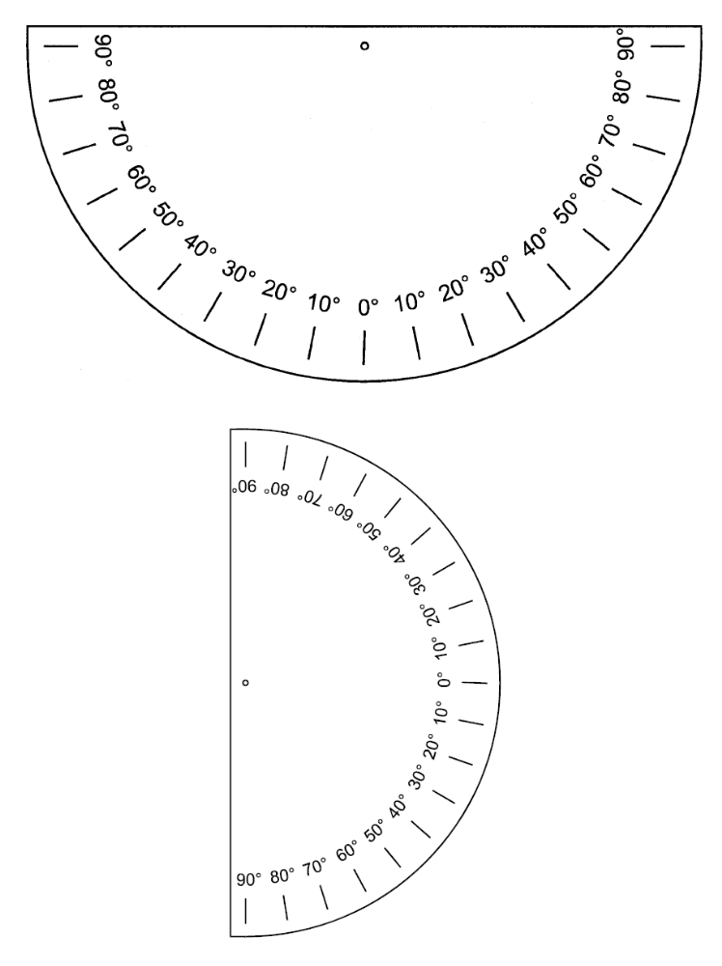
Locating Celestial Objects in the Night Sky

Objective: Using an astrolabe and a compass determine the altitude and azimuth of celestial objects in the night sky.

Materials
Student constructed astrolabe
Compass for measuring azimuth
Observation Chart
Star Chart

Activity procedure:
The activity is to be done on students own time, recordings are to be taken twice weekly for the next three weeks.

- Select 3 to 5 objects in the night sky that you wish to locate. It is important to check that the object you have chosen will be visible during the time you are doing the activity. i.e.) some celestial objects or only visible during certain times of the year. A possible objects that could be located are The Moon, Polaris (the North Star), the stars Dubne and Merak, Venus, Mars, Jupiter etc. Students will be provided with a star chart and directions on how to use it to locate stars in the sky.

- Determine the azimuth of your selected objects using the compass. As you have already learned azimuth is determined by visually tracing a line from the object straight down to the nearest horizon point, and reading its compass bearing. Record the bearing in your observation chart. Remember 90۫۫۫۫۫ would be due east, 180۫ would be due south, 270۫ would be due west, 0۫ or 360۫ would be due north.

- Using the astrolabe, look through the straw until you can locate the object in the field of view. To find the altitude of the object you need to pinch the string with your free hand, against the scale on the astrolabe. Record the object’s altitude in the observation chart. To increase the accuracy of your reading, perform this step two or more times for each object.

- Be prepared to discuss your results with a classmate or group on how you determined your readings. It may be useful to arrange for you and another classmate to observe the same objects at the same time, so that you can compare results.

Date and Time of Observation | Objects Viewed | Azimuth  (in degrees)  from compass | Altitude as measured by Astrolabe
1st Observation
2nd Observation
3rd Observation
4th Observation
5th Observation
6th Observation

Star Chart Procedure

- Use your compass to make yourself face North.
- Find the Meridian in the sky and on the star chart using the date.
- Find the field of view on the star chart and compare the stars seen on the chart with those in the sky.

The meridian is an imaginary curve that passes through the north horizon, the North Star (Polaris), the point directly overhead (zenith) and the south horizon as shown below. Note that Polaris is not the brightest star in the sky. You can use Dubhe and Merak of Ursa Major as pointer stars to help you find Polaris.

The meridian on the star chart can be located using the date. The dates along the outer edge of the chart represent the location of the meridian.

SFA Star Chart" - Northern Region



